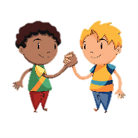
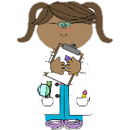

What Am I Learning?
Keeping Safe – Internet Safety
Family and Friends – Friendship
Rules and Responsibilities – Rules, Expectations and Taking Turns.

I can:
Learn the importance of using the internet / To keep safe and how to get help / To develop positive relationships with peers / Identify and respect the differences and similarities between people / To develop positive relationships between work and play / understand the reason why we have rules / Suggest rules that would improve things for the common good / To take turns and share.

I am
an Aspirational
Citizen!
What Am I Learning?
To develop our understanding
of technology and how it can
help them in their everyday lives.
We will learn about the different components of a computer by developing keyboard and mouse skills. We will also consider how to use technology responsibly.
I can:
Identify different uses of technology in the world / identify a mouse and keyboard / develop keyboard and mouse skills / use a computer responsibly.

What Am I Learning?
To identify deciduous and evergreen trees.
To identify a variety of trees.
To name parts of a tree.

I can:
Name the trunk, roots and leaves.
I will know that trees have blossom, branches and bark. I can explain that evergreen trees don’t lose their leaves in Winter and that deciduous trees do. I will identify trees within the school grounds. I will identify signs of autumn.

I am a
SuperScientist!
I am a Confident Computer
Technician!


I am a
Majestic Musician!
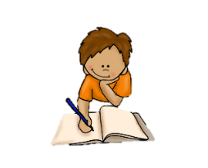
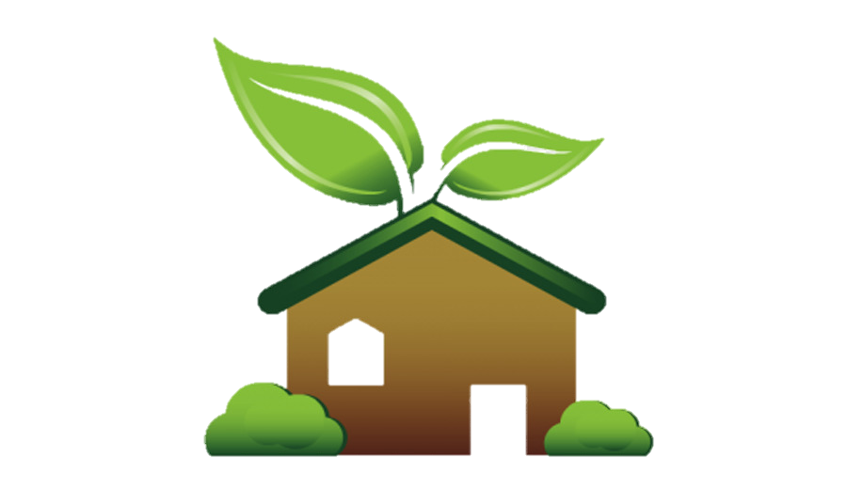
I am a Remarkable Reader and Writer!

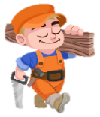
I am a Daring Design Technician!

Focus Books: Errol’s garden by Gillian Hibbs and Jack and the beanstalk.
What Am I Learning? To write a character description about the main character of a story. Retell the story of Jack and the beanstalk. To write instructions on how to make a smoothie.
I can now…
Use adjectives to describe what a character looks like and his personality. Recall the events of a story. I can write step-by-step instructions in chronological order using imperative verbs.
What Am I Learning?
To design purposeful, functional, appealing product for myself and other users based on design criteria. To use the basic principles of a healthy and varied diet to prepare dishes. To evaluate their ideas and products against design criteria

I can: Suggest suitable healthy ingredients to make a smoothie, use tools safely to cut and shape, evaluate my own and others products identifying ways in which they can be improved.

Year 1
Curriculum Map – The Green, Green Green Grass of Home!

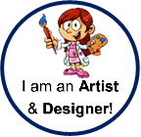
What Am I Learning? To learn about the work of other artists, making links to my own work. To create a clay sculpture. To print. To mix primary colours to make secondary colours

I can:
To know who Barbra Hempworth is / use clay working skills to make a sculpture in the style of Barbra Hempworth / to know who Lynn Flavell is / to use printing to create a piece of art work in the style of Lynn Flavell / To know what the primary colours are / To know how to mix colours / To know what the secondary colours are

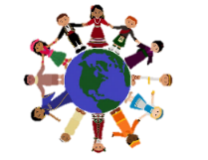
What Am I Learning? What are worldviews and how do we find out about them? What do Christians believe about God and why?
I will find out: What Christians believe in? Why do Christians believe God is a special person? What do Christians believe about God? What do religious stories say about how the world began? How should we live together to look after each other and animals?

. T
I understand
Diversity!
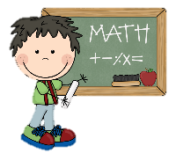
I am a Magnificent
Mathematician!
At Glastonbury Thorn School, we follow White Rose maths and the National Centre for Excellence in Maths.
What Am I Learning?
Place value within 10

I can:
Sort objects / Count objects / Count objects from a larger group / Represent objects / Recognise numbers as words / Count on from an number / Counting 1 more and 1 less / Count backwards within 10 / Compare groups by matching / Understanding fewer, more and same / Understanding less than, greater than and equal to / Compare numbers / Order objects and numbers / Use a number line.


I am a Geographer!
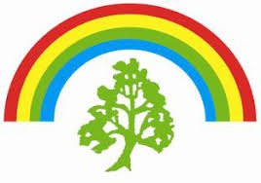
What Am I Learning? – To know the human and physical features of the seaside

I can: Name Southend as a seaside town / know the human features of Southend / know the physical features of Southend

What Am I Learning? To master basic movements and begin to apply these to a
range of activities.
I can: run safely whilst changing speed. Jump into a space,
landing safely & show how to combine jumps.
Throw a variety of objects with an underarm throw towards a
target & begin to throw overarm

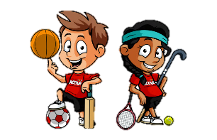
T
I am a Sports
Star!
Year 1 Curriculum Map – Autumn 1!


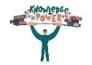
WOW!
Making a smoothie

Through our science topic we will have a greater knowledge of plants and what they need in order to survive. We will have an appreciation of how changes in the weather affects plant growth. We will be able to recognise and name a variety of garden and wild plants.
Knowledge

EXPERIENCE! A visit to our personal Year 1 beach. A trip to the seaside via Google Earth

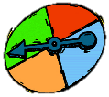
Possibilities
Learning about plants will help us develop our enquiry skils, asking questiions and making predictions. We will learn that plants can grow on a varity of different conditions.

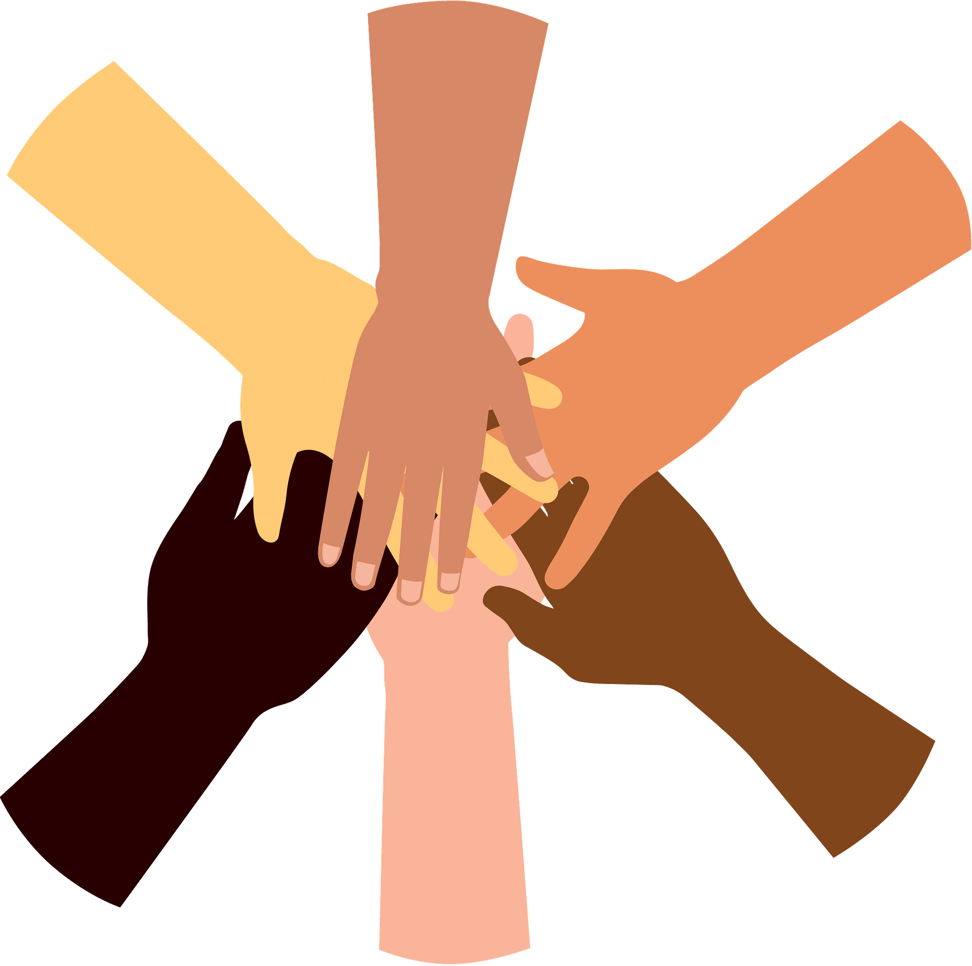
Through our continued study of the UK, we will increase our knowledge of places beyond Milton Keynes, understanding how places are similar and what makes them different.

Diversity
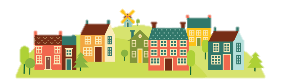
Community
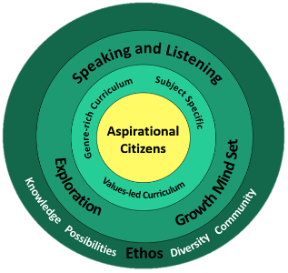
CREATE!
Clay sculptures in the style of Barbra Hempworth

We will be learning how to cooperate and show kindness to each other, learning to be aspirational citizens.

Every day getting better in every way!


Glastonbury Thorn School
Year 1 – Autumn 1!

