Glastonbury Thorn School
Maths KIRFs
(Key Instant Recall Facts)
Year 2, Spring 2
Multiplication and Division Facts – Two Times Table

As part of your weekly maths homework, we would like you to learn these facts. By the end of the half term, children should be able to recall these with speed and accuracy.
Children will be assessed on their knowledge of these facts at the end of each half term.
If you know three time two is six, then what is six divided by two?
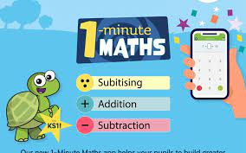
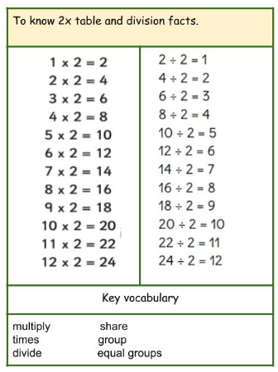
Practical Ideas:
- Make a bingo game
- Make a matching pairs game
- WhiteRose App
- How many multiplication/division questions can you answer in 1 minute?

Top tips

The secret to success is practising little and often. Use time wisely. Can you practise this KIRF whilst eating breakfast, walking to school or during a car journey? We recommend that you practise for just a few minutes each day.
Solve word problems involving multiplication and division, e.g. if sweets cost 2p and I buy 6, how much money would I need?

