Glastonbury Thorn School
Maths KIRFs
(Key Instant Recall Facts)
Year 1, Summer 2
Counting in 2’s, 5’s and 10’s

As part of your weekly maths homework, we would like you to learn these facts. By the end of the half term, children should be able to recall these with speed and accuracy.
Children will be assessed on their knowledge of these facts at the end of each half term.
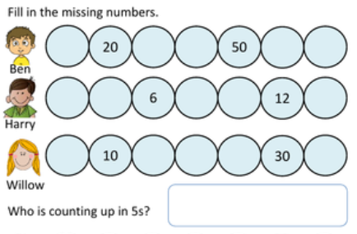
Examples:



Top tips
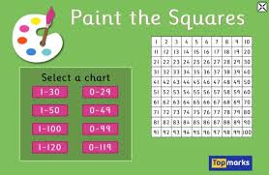
The secret to success is practising little and often. Use time wisely. Can you practise this KIRF whilst eating breakfast, walking to school or during a car journey? We recommend that you practise for just a few minutes each day.
Practical Ideas:
- Make flash cards
- Quick fire game – How many questions can you answer correctly in 1 minute?
- Make a pairs game, can you match questions and answers?
- WhiteRose App/ www.topmarks.co.uk


