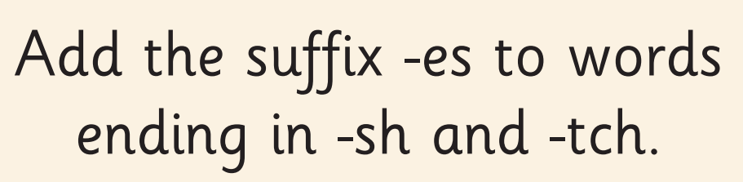
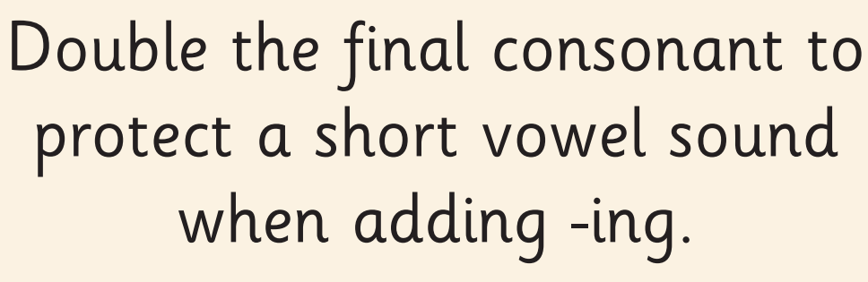
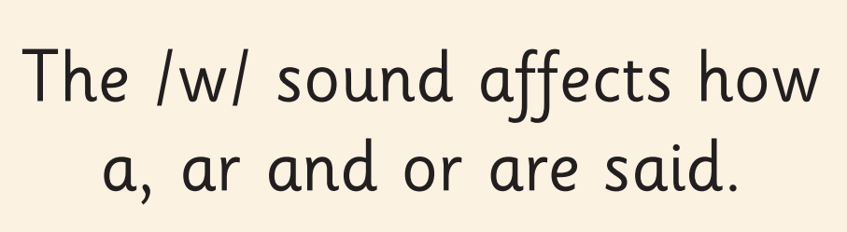
These are the spelling rules we have been practising this week!
Practise writing these words. Can you write a sentence using any of these words?

want | work | towards | wasp
squashes | watches | washes | switches
wagging | swimming | swapping | running

