
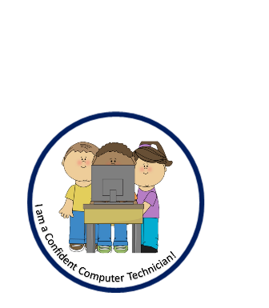
What does it mean to be a digital leader at GTS

Skill | Aspirational citizen in EYFS | Aspirational citizen in Year 1 | Aspirational citizen in Year 2
Algorithms and programming | - Can verbally follow instructions | - To understand what an algorithm is: a series of instructions  - To create a series of instructions.  - To plan a journey for a programmable toy. | - To understand why algorithms are needed on digital devices.  - To understand that programs require precise instructions.  - To predict what the outcome of a simple program will be (logical reasoning).  - To test and amend a set of instructions.  - To write a simple program and test it.
Being a safe user knowledge and understanding | - Children gain an understanding of being a safe user online through our whole school online safety day  - To understand who a trusted adult is | - To understand what a ‘pop up’ is and who to tell if something pops up while they are online  - To know I must tell a trusted adult immediately if anyone tries to meet me via the internet.  - To know that I must not share my personal information online  - School is aware of the games applicable to children in GTS and shares documents with parents on how to ensure that our children keep safe on those sites; Roblox being the main one from pupil voice. | - To understand what a safe online user is and to demonstrate being one at GTS  - To understand how to bookmark safe sites  - To know to tell a trusted adult if I am unsure of any online activity  - To demonstrate being a safe user at Hazard Alley  - To know how to send and receive an email safely – from and to sources that I know. Send an email to the Head teacher of their new school.  - To use the internet safely independently
Skills and digital Literacy | - To look at a range of digital sources and explore digital resources | - Use technology purposefully to create, organise, store, manipulate, and retrieve digital content – making E cards for our Christmas cards linked to PSHE –  - Create an animal fact file linked to their science learning  - Know how to save and retrieve their work  - Create simple digital content – weather report linked with their Geography and Science learning  Aspirations: Professional - Weather Reporter:  Des Coleman  Laura Tobin | - To use the internet for learning, making choices when navigating through sites.  - To be able to explain the different methods of communication and when we might use them for which purpose.  - To be able to use a multi-media presentations to show/ present information.  - Be able to edit and enhance photos

