Homework- Friday 7th March 2025
For your homework, we would like you to imagine you’re in Mr McGregor’s garden! Use your senses to describe what you would see, hear and smell! Complete the senses grid below.

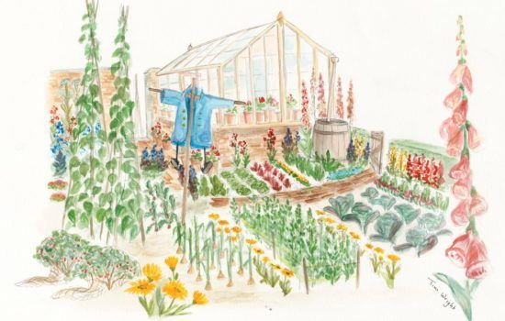

Digging Deeper- Can you use adjectives in your description?

 |  | 
I can see…  a tall scarecrow. | I can hear…  birds singing beautifully. | I can smell…  ripe, tasty vegetables.

